8.53: Solving for the magnitude of 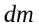in Eq. (8.39),

